Project Design Phase-II
Technology Stack (Architecture & Stack)

Date | 19 February 2026
Team ID | LTVIP2026TMIDS45121
Project Name | shopsmart: your digital grocery store experience
Maximum Marks | 4 Marks

Technical Architecture:
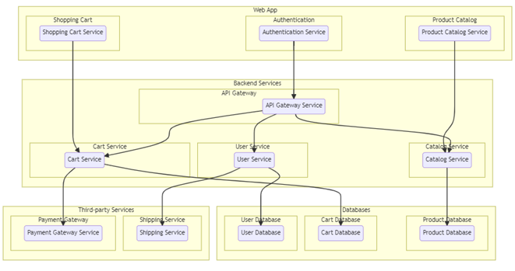

Table-1: Components & Technologies:

S. No | Component | Description | Technology
 | User Interface | Web application where users and admin interact (Product browsing, cart, dashboard) | React.js, HTML5, CSS3, JavaScript
 | Application Logic-1 | Authentication & Authorization (Login, Register, JWT validation) | Node.js, Express.js, JWT, bcrypt
 | Application Logic-2 | Product Catalog Management (CRUD operations for products) | Express.js, REST APIs, Node.js
 | Application Logic-3 | Cart & Order Processing Logic | Node.js , Express.js,
 | Database | Stores Users, Products, Cart, Orders, Reviews | MongoDB, Mongoose
 | Cloud Database | Database hosting in cloud | MongoDB Atlas
 | File Storage | Product images storage | Cloudinary / Local File System
 | External API-1 |  | Stripe API / Razorpay API
  Payment Gateway Integration
 | External API-2 | Email Notification Service | Nodemailer / SendGrid
 | Machine Learning Model | Product Recommendation (future enhancement) | Recommendation Algorithm
 | Infrastructure (Server / Cloud) | Application deployment | Local Server (Development), Render / Vercel / AWS (Production)

Table-2: Application Characteristics:
S. No | Characteristics | Description | Technology
 | Open-Source Frameworks | Frontend and Backend frameworks used | React.js, Node.js, Express.js
 | Security Implementations | Password hashing, JWT authentication, role-based access control | bcrypt, JWT, CORS, Helmet
 | Scalable Architecture | 3-Tier Architecture (Frontend – Backend – Database) | REST Architecture, MongoDB
 | Availability |  | MongoDB Atlas, Cloud Hosting
  Hosted on cloud with uptime reliability
 | Performance | Fast API response and optimized queries | Express Middleware, Indexed MongoDB

